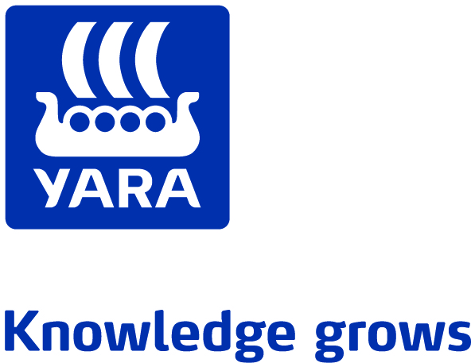

**To the shareholders of Yara International ASA**

**Notice of Annual General Meeting 10 May 2016**

Notice is hereby given of the Annual General Meeting of Yara International ASA (the "**Company**"). The Annual General Meeting will be held at the Auditorium, Drammensveien 131, 0277 Oslo **on Monday 10 May 2016 at 17:00 CEST.**

In accordance with the Public Limited Companies Act (Norway) sections 5-12 (1) and 5-13, the General Meeting will be opened by Leif Teksum, Chairman of the Board of and a record of the shareholders who are present either in person or by proxy will be made.

The following matters are on the agenda of the meeting:

1. **Opening of the general meeting, approval of meeting notice and agenda**
2. **Election of chairperson and a person to co-sign the minutes**

The Board proposes that Ketil E. Bøe, partner in the law firm Wikborg, Rein & Co is elected as Chairperson.

1. **Approval of the annual accounts and the annual report for 2015 for Yara International ASA and the group, including distribution of dividends**

The Board proposes that a dividend of NOK 15.00 per share is paid for the financial year 2015.

1. **Statement regarding determination of salary and other remuneration to the executive management of the Company**

Pursuant to section 6-16a of the Norwegian Public Limited Companies Act, the Board is required to prepare a statement on the stipulation of the guidelines for salaries and other remuneration to the senior management of the Company. Pursuant to section 5-6 (3) of the Norwegian Public Limited Companies Act, such statement shall be considered by the Annual General Meeting. The Board’s statement is attached to the notice.

The General Meeting shall carry out a consultative vote regarding the company's guidelines for salaries and other remuneration to senior management for the coming accounting year, and the Board proposes that the General Meeting endorses the guidelines.

The General Meeting shall furthermore approve any equity-based remuneration to senior management. None of the elements described in the guidelines concern equity-based remuneration and such approval is therefore not required.

1. **Report on Corporate Governance**

Pursuant to section 5-6 (4) of the Norwegian Public Limited Companies Act, the Annual General Meeting shall consider the Board’s report on Corporate Governance. The Corporate Governance report is included on pages 30-37 in the annual report for 2015.

The Board proposes that the General Meeting takes note of the report.

1. **Auditor's fees for the audit of Yara International ASA for the financial year 2015**

The Board proposes an auditor remuneration of NOK 3,650,000 for the financial year 2015.

1. **Remuneration to members of the Board, members of the Compensation Committee and members of the Audit Committee for the period until the next Annual General Meeting**

The Nomination Committee proposes the following remuneration for Board members:

Chairman of the Board: NOK 529,000

Vice Chairman of the Board: NOK 349,000

Members of the Board: NOK 305,000

The remuneration is per year and is calculated accordingly.

The Nomination Committee proposes the following meeting allowance for Board members resident outside Scandinavia:

NOK 11,000 per meeting

The Nomination Committee proposes the following remuneration for the deputy representatives to the Board:

NOK 9,600 per meeting

The Nomination Committee proposes the following remuneration to the members of the Compensation Committee:

NOK 7,000 per meeting

The Nomination Committee proposes the following remuneration to the members of the Audit Committee:

Chairman of the Audit Committee: NOK 156,000

Members of the Audit Committee: NOK 90,500

The remuneration is per year and is calculated accordingly.

1. **Remuneration to the members of the Nomination Committee for the period until the next Annual General Meeting**

The Nomination Committee proposes the following remuneration to the members of the Nomination Committee:

NOK 5,700 per meeting

1. **Election of members of the Board**

The Company has the following Board of Directors:

Leif Teksum (chair)

Maria Moræus Hanssen (vice chair)

Hilde Bakken

Geir Isaksen

John Thuestad

Rune Bratteberg (employee representative)

Guro Mauset (employee representative)

Geir O. Sundbø (employee representative)

Reference is made to the enclosed proposal from the Nomination Committee. The Nomination Committee proposes the re-election for a period of two years of Leif Teksum, Maria Moræus Hanssen, Hilde Bakken, John Thuestad and Geir Isaksen as Board members.

The Company will according to this proposal have the following shareholder-elected Board members:

Leif Teksum

Maria Moræus Hanssen

Geir Isaksen

Hilde Bakken

John Thuestad

1. **Election of members of the Nomination Committee**

The Nomination Committee has the following members:

Tom Knoff (chair)

Thorunn Kathrine Bakke

Ann Kristin Brautaset

Anne Carine Tanum

Reference is made to the enclosed proposal from the Nomination Committee.

The Nomination Committee proposes the re-election for a period of two years of Tom Knoff, Thorunn Kathrine Bakke, Ann Kristin Brautaset and Anne Carine Tanum as members of the Nomination Committee.

The Nomination Committee suggests that the proposal for members of the Nomination Committee is considered in a joint vote.

1. **Capital reduction by cancellation of own shares and by redemption of shares held on behalf of the Norwegian State by the Ministry of Trade, Industry and Fisheries**

On 11 May 2015 the General Meeting authorized the Board of Directors to acquire up to 13,754,168 own shares with a nominal value of up to NOK 23,382,086 in the equity market and from the Norwegian State. Within this frame, the Company has acquired 1,190,000 shares with a total nominal value of NOK 2,023,000. The Board proposes that these shares shall be cancelled by reduction of the Company's share capital. The Norwegian State has committed itself to participate on a pro-rata basis in the capital reduction. This means that the Norwegian State’s ownership interest of 36.21% remains unchanged. The total consideration for the buy-back and redemption of the Norwegian State’s shares amounts to NOK 716,508,423. Based on the above, the Board proposes that the General Meeting passes the following resolution:

*“The share capital of the Company is reduced by NOK 3,171,416.30 from NOK 467,641,727.30 to NOK 464,470,311 by cancellation of 1,190,000 of the Company's own shares and redemption of 675,539 shares owned on behalf of the Norwegian State by the Ministry of Trade, Industry and Fisheries, for a payment of NOK 259,458,196 with addition of interest and adjusting for paid dividend to the Norwegian State represented by the Ministry of Trade, Industry and Fisheries. This sum represents the average share price paid for the buyback of own shares in the market. The portion of the sum paid to acquire and redeem shares that exceeds the nominal value of the shares will be covered by a transfer from retained earnings of NOK 713,337,007.*

*With effect from the implementation of the capital reduction through registration in the Register of Business Enterprises, Article 4 of the Company’s Articles of Association will be amended to read as follows:*

*The share capital is NOK 464,470,311 divided into 273,217,830 shares, each with a nominal value of NOK 1.70.”*

1. **Power of attorney to the Board regarding acquisition of own shares**

The Board proposes that the General Meeting approves a new authorization for acquisition of own shares. The existing authorization of the Board will be cancelled at the same time. The purpose of such a new authorization is to allow the Board to optimize the Company’s capital structure through buy-back and subsequent cancellation of shares.

The authorization is limited to a total purchase of up to 5% of the total share capital of the Company.

The Board proposes that the General Meeting passes the following resolution:

*"(a) The General Meeting hereby authorizes the Board to acquire up to 5% (13,660,891 shares) of the share capital of the Company in the open market and from the Norwegian State.*

*(b) The purchases of own shares shall be at terms determined by the Board. The purchase price per share shall not be less than NOK 10 and not more than NOK 1,000.*

1. *The shares acquired pursuant to this authorization shall be subsequently cancelled.*
2. *This authorization is valid from 11 May 2016 until the next Annual General Meeting but no later than 30 June 2017.*

*It is a condition precedent for any purchase and subsequent cancellation of shares that the Norwegian State’s ownership (presently 36.21%) is not changed as a result of this."*

--------------------------------

***Shareholders’ rights***

The share capital of the company consists of 275,083,369 shares, each with a face value of NOK 1.70. Each share carries one vote at the general meeting, however no voting rights can be exercised for shares owned by the Company. The Company owns 1,190,000 of its own shares today.

A shareholder is entitled to vote according to the number of shares owned and registered with the Norwegian Central Securities Depository (VPS) at the date of the General Meeting. If a shareholder has acquired shares that are not registered in VPS at the time of the General Meeting, the voting rights for the transferred shares may only be exercised if the transfer has been reported to the VPS and proved prior to the General Meeting. Shareholders have the right to bring an advisor, which may speak on behalf of the shareholder in the General Meeting.

If shares are registered by a nominee in the VPS register, cf the Norwegian Public Limited Liability Companies Act Section 4-10, and the beneficial shareholder wants to attend the General Meeting and vote for his shares, the beneficial shareholder must submit a written confirmation from the nominee that the shareholder is the beneficial owner of the shares, and a statement from the shareholder confirming that he is the beneficial owner of the shares.

A shareholder has the right to have matters dealt with by the General Meeting which he or she reports in writing to the Board of Directors in such good time that it can be entered on the agenda, or if there are at least three weeks left before the date of the General Meeting, so that a new notice can be sent. Matters that are not on the agenda may not be decided at the meeting. Further, a shareholder is entitled to ask members of the Board and the general manager to provide information in accordance with section 5-15 of the Norwegian Public Limited Liability Companies Act. Shareholders are entitled to present alternatives to the Board's proposal under the current items of the agenda, provided that the alternative proposals are within the scope of the matter under consideration. Proposals for candidates for election to the Board of Directors and/or the Nomination Committee may also be submitted during the general meeting.

Shareholders who wish to attend the General Meeting are requested to give notification as soon as possible and at the latest by Monday 9 May 2016 12:00 CEST to:

DNB Bank ASA

Verdipapirservice

PO Box 1600 Sentrum

N-0021 Oslo

E-mail: genf@dnb.no

Telephone: +47 23 26 80 21

Attendance can also be registered electronically through the Company’s website at [www.yara.com](http://www.yara.com)/register linked to Verdipapirservice.

A shareholder who has not given notice within the date stated above may be denied access to the general meeting. Any shareholder may appoint a proxy with written authority to attend the meeting and to vote on his or her behalf. Admission cards to the General Meeting will not be issued. Attached you will find a combined attendance- and power of attorney form.

This notice, other documents regarding matters to be discussed in the General Meeting, including the documents to which this notice refers, nominations for positions on the Board, as well as the company’s Articles of Association, are available at the Company’s web site:

http://www.yara.com/about/corporate_governance/shareholders/annual_general_meetings/index.aspx

Shareholders may contact the company by ordinary mail or email in order to request the documents in question on paper.

Address:

Yara International ASA, c/o Wittusen & Jensen, PO Box 115 Kalbakken, N-0902 Oslo.

E-mail: [omb@wj.no](mailto:omb@wj.no)

Documents that the notice refers to which only are available at the company’s web site [www.yara.com](http://www.yara.com):

* Annual accounts, annual report and auditor’s report for the financial year 2015
* The Nomination Committee’s proposal

Oslo, 18 April 2016

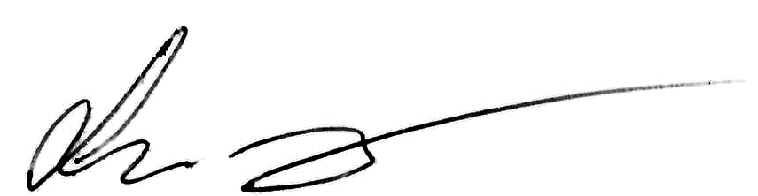

Leif Teksum, Chairman, by authorization of the Board of Directors

Enclosure:

Form for notification of participation or appointment of proxy

Statement on remuneration of executive management